

JSS-01
JavaScript Software Synthesizer

Michael Kolesidis

What is Sound?

In physics, sound is a vibration that spreads as an acoustic wave, through a transmission medium such as a gas (the air) , liquid or solid.

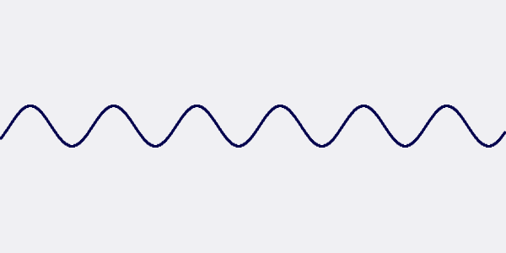

What is a Synthesizer?

A synthesizer is an electronic musical instrument that generates audio signals.

Hardware Synthesizers

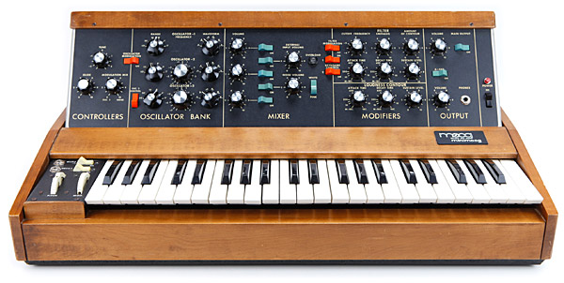

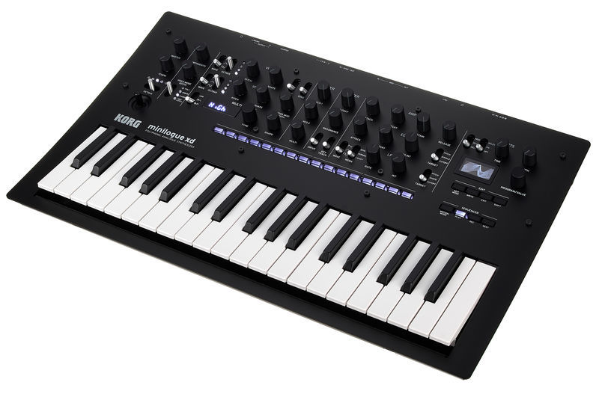

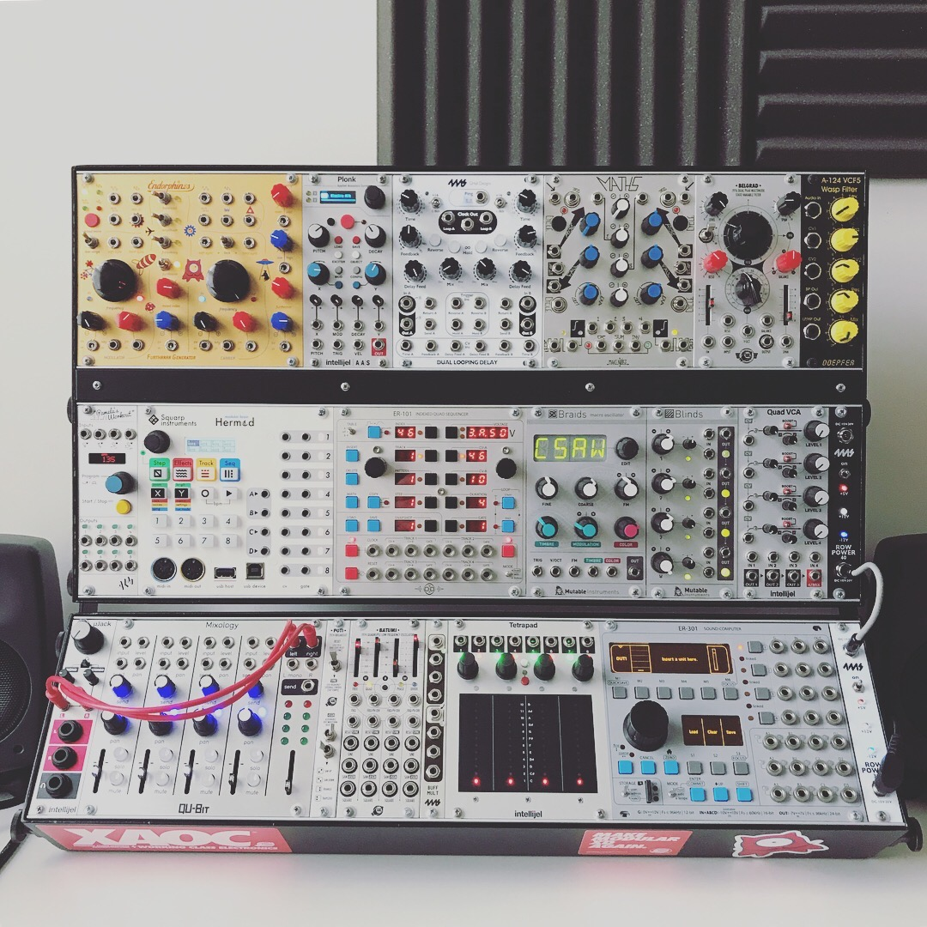

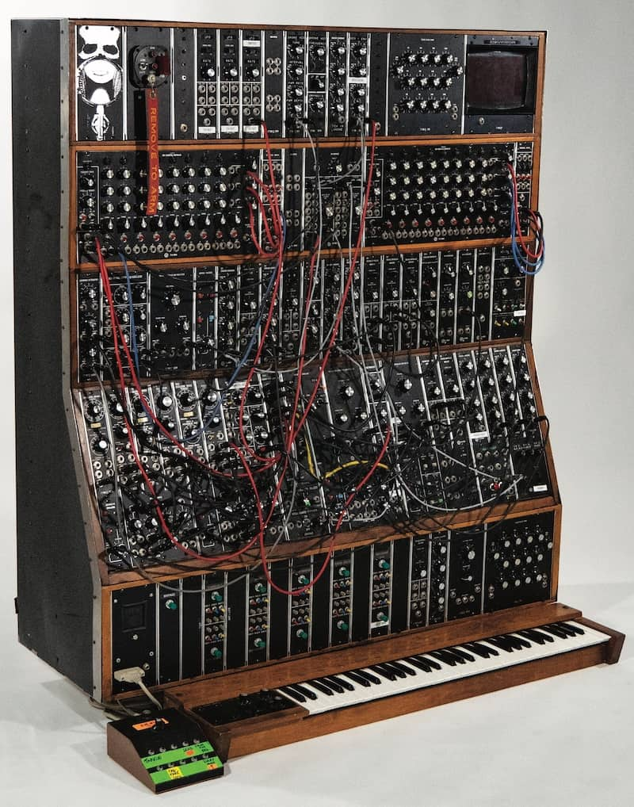

Software Synthesizers

Emulate the functions of hardware synthesizers
(usually written in C++)

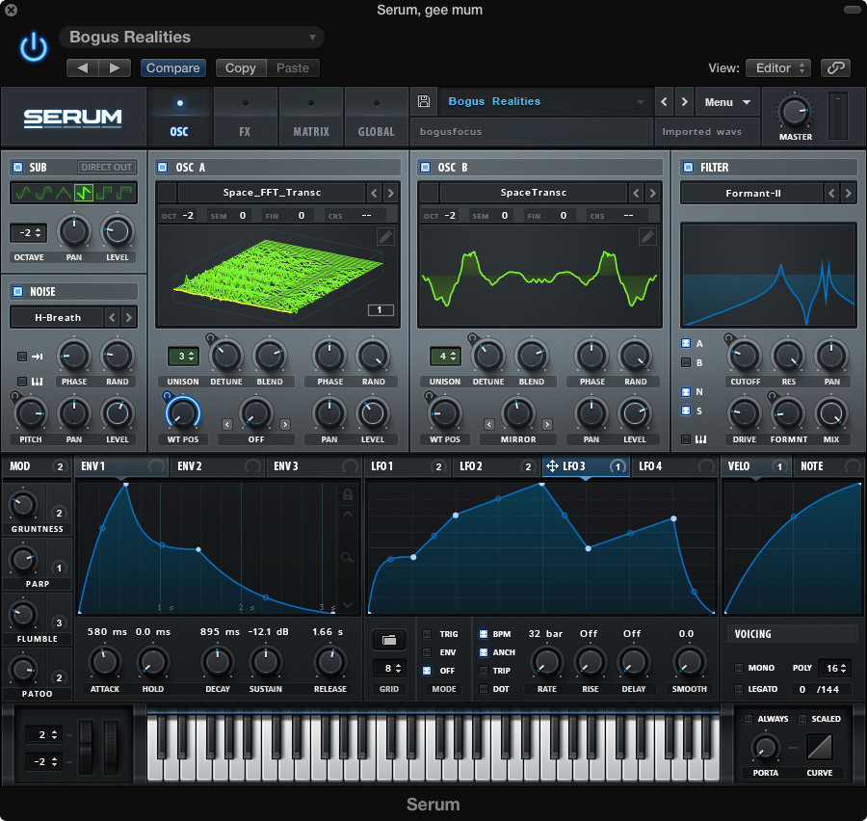

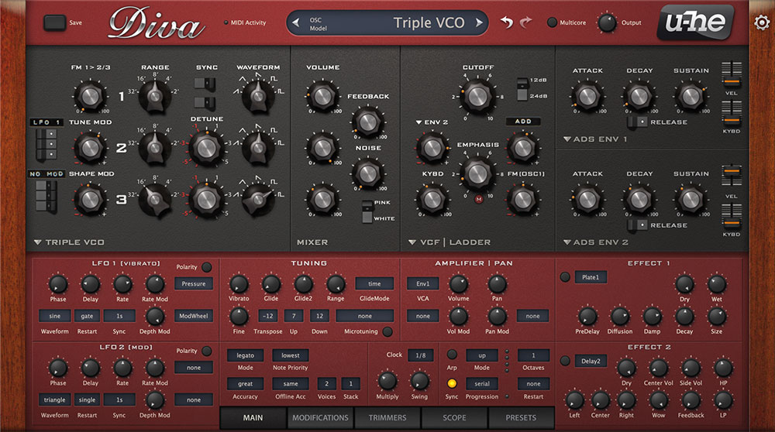

Remember:
Sound is a WAVE!



Oscillator

An electronic oscillator is an electronic circuit that produces a periodic, oscillating electronic signal, often a sine wave or a square wave or a triangle wave.

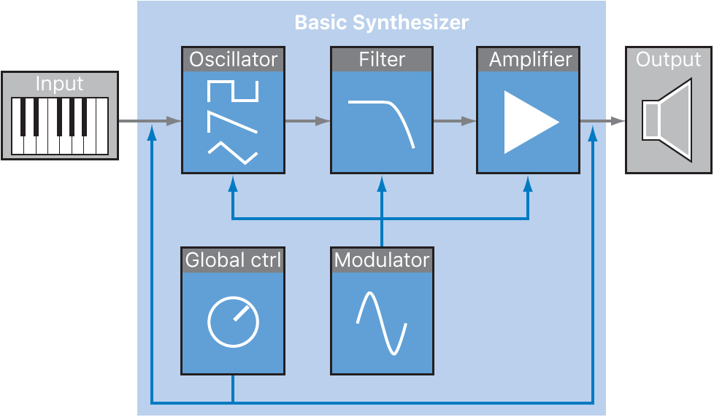

Wave Frequency

Wave frequency is the number of waves that pass a fixed point in a given amount of time.

FM Synthesis
Frequency Modulation Synthesis

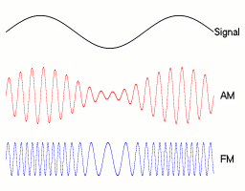







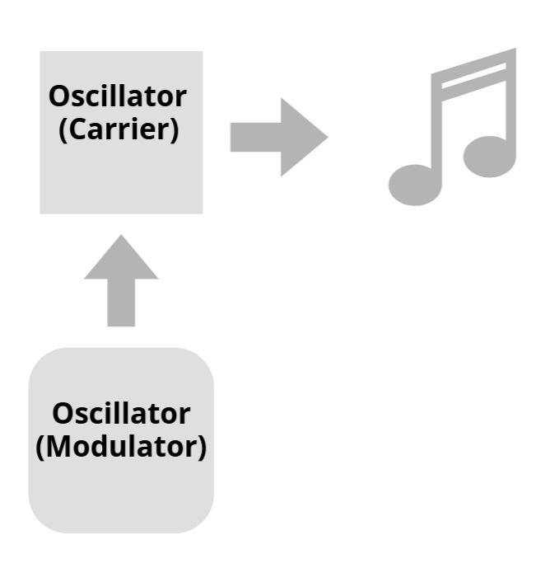

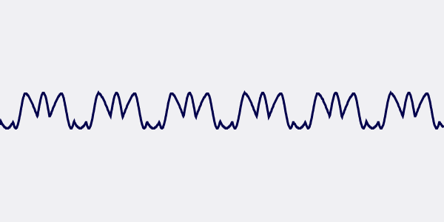

Technologies

NexusUI

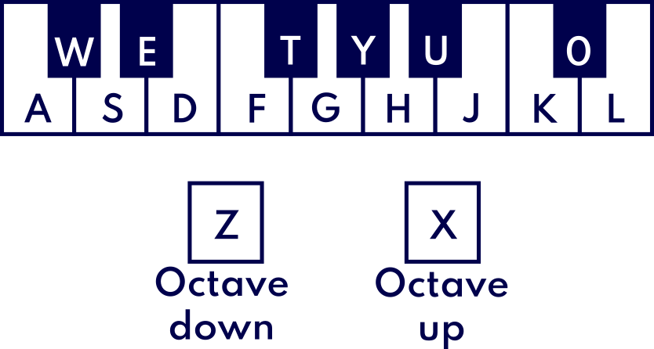

Controls

Three ways to play the synthesizer
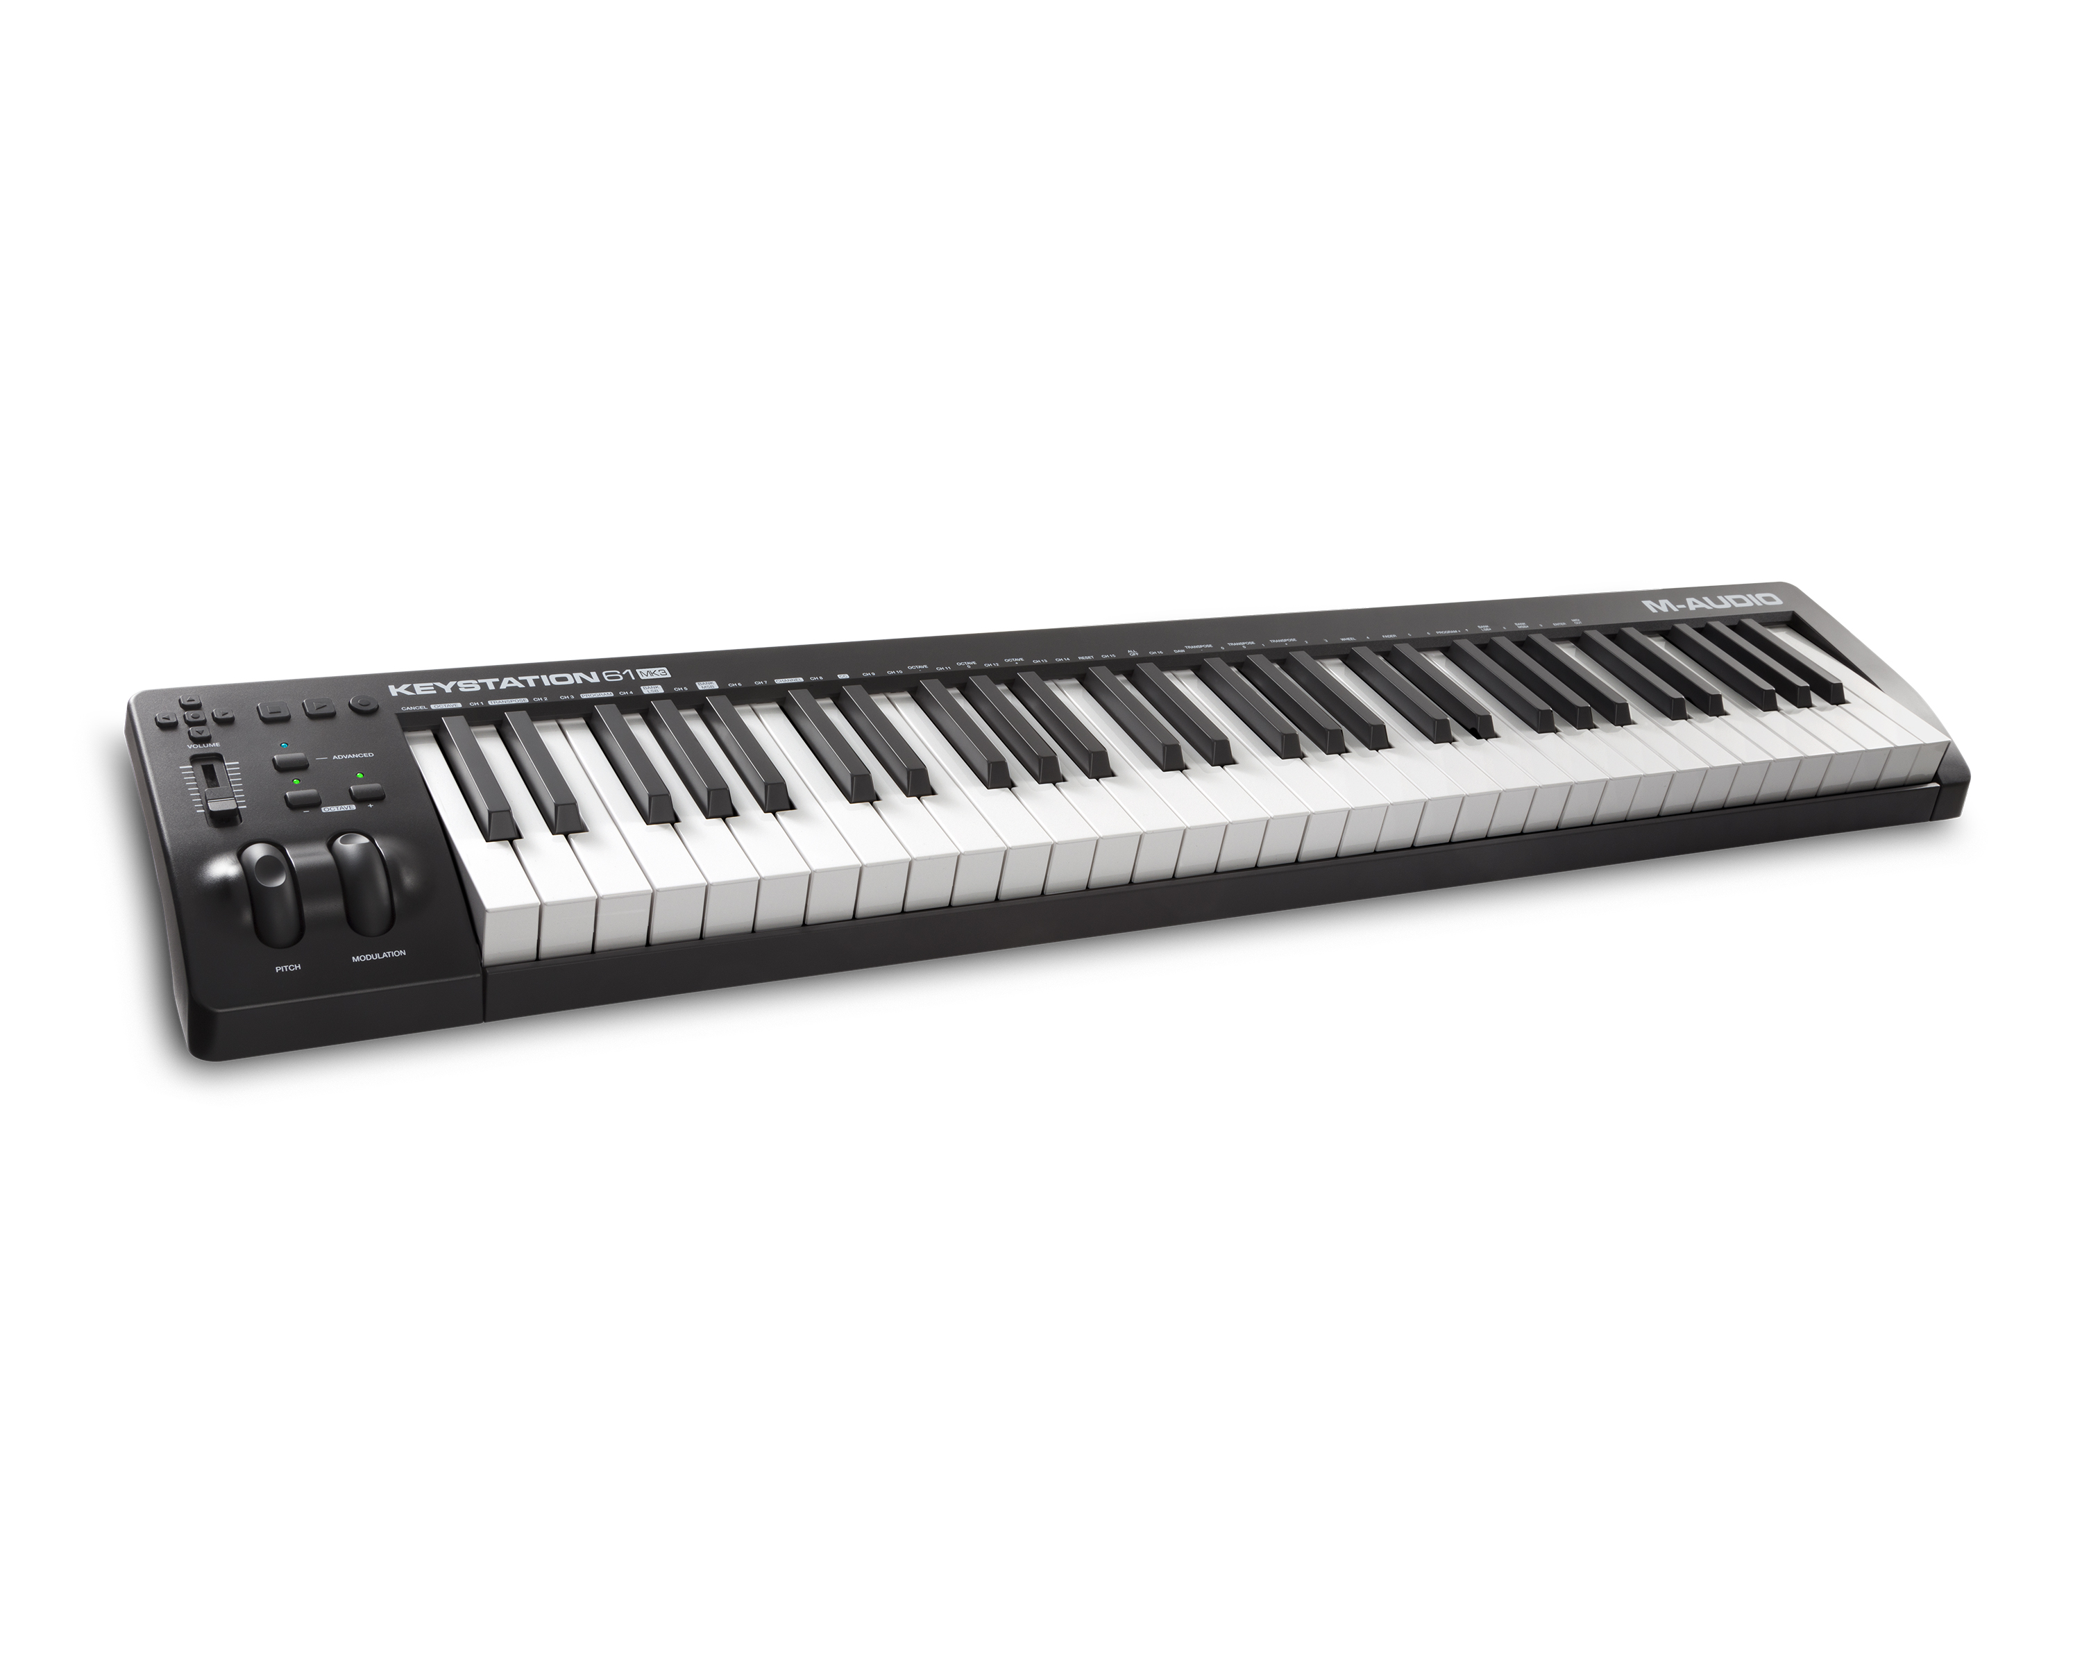
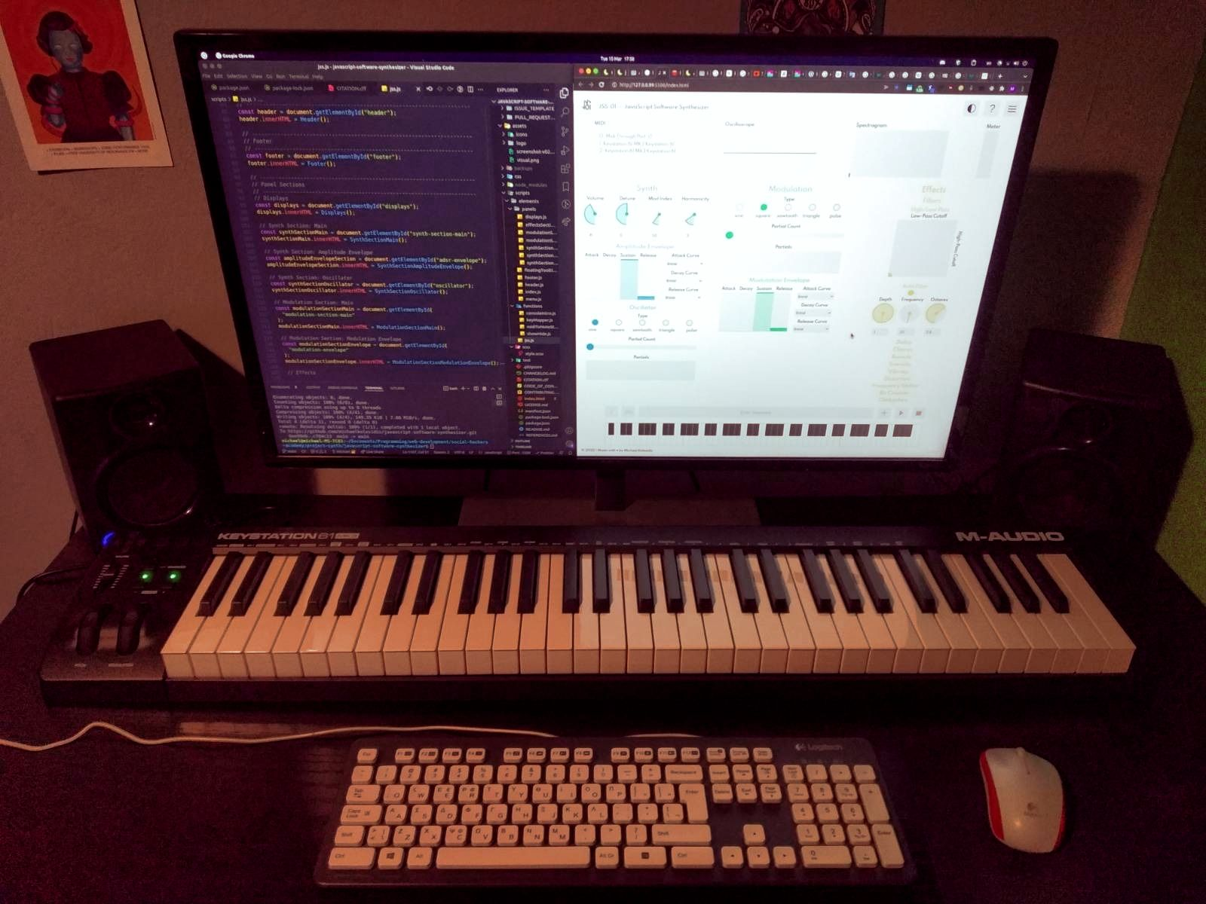

On-screen keyboard

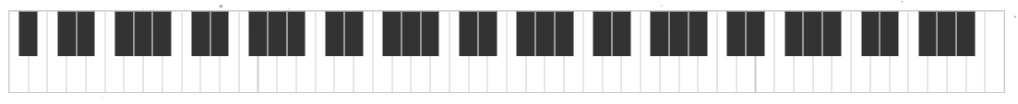

Computer keyboard

MIDI Keyboard

Future Plans

Create a community!

- Dark Mode
- Help Mode with tooltips on hover (using the FloatingUI library)
- Presets to save the various configurations
- Full MIDI implementation with ability to choose input device and support for MIDI controllers
- Recorder
- Responsive Design
- Support more types of synthesis (additive, subtractive etc.)
- Switch to TypeScript
- Switch to React

Copyright (c) 2022 Michael Kolesidis
^{Licensed under the MIT License}

